Reflective Account on Team-Based Development of a Digital Forensic Agent
1. Description
Throughout this module, I worked as part of a development team tasked with the design of a Digital Forensic Agent-based System (ABS). The goal of the project was to design a multi-agent solution capable of locating, preserving, analysing, and reporting on digital evidence in a way that is auditable, repeatable, and compliant with forensic and regulatory standards. The system followed a hybrid agent architecture, with a BDI-style Coordinator agent orchestrating specialist reactive agents responsible for discovery, hashing, storage, and reporting.
Alongside the group project, I completed several individual learning activities, including syntactic analysis using constituency-based parse trees, the construction of a KQML/KIF agent dialogue, and multiple discussion contributions on agent communication languages and deep learning ethics. These activities were not isolated tasks; rather, they fed directly into how I approached agent design, communication, and reasoning within the team project.
My primary individual contributions to the group project were the development of the domain ontology and shared vocabulary, the specification of First-Order Logic (FOL) constraints, and the formalisation of agent communication semantics. These artefacts formed a conceptual backbone for the system, ensuring clarity, correctness, and shared understanding across the team.

2. Feelings
At the start of the module, I felt motivated but apprehensive. I was confident in my technical background but aware that agent-based systems require a different mindset from traditional monolithic or service-oriented software. In particular, I was concerned about ambiguity: agent systems can easily fail if assumptions about meaning, responsibility, or message intent are not shared consistently.
As the project progressed, my confidence increased significantly. I found that working on formal artefacts such as ontologies and FOL rules gave me a sense of control and intellectual clarity. However, I also experienced moments of frustration, especially when informal discussions within the team risked glossing over semantic precision. These emotions influenced my behaviour by pushing me to advocate more strongly for explicit definitions and constraints, rather than relying on implicit agreement.

3. Evaluation
One of the strongest aspects of our team’s work was the clear separation of responsibilities across agents, aligned with established forensic process models. The Coordinator–Surveyor–HasherPacker–Scribe structure supported traceability and auditability, which are critical in forensic contexts (Reith, Carr and Gunsch, 2002; Wooldridge, 2009).
From my perspective, a key positive was the team’s openness to formal methods. My contributions around ontology design and FOL constraints were accepted and incorporated into the final design, improving consistency and reducing ambiguity. The main weakness was that these artefacts were introduced slightly later than ideal; had they been established earlier, some design discussions could have been resolved more efficiently.

4. Analysis
My learning across the module was cumulative and interconnected. The constituency-based parse tree exercise initially appeared linguistic in nature, but it sharpened my awareness of structural ambiguity. For example, analysing the sentence “The man saw the dog with the telescope” highlighted how meaning can change depending on attachment. I later recognised the same risk in agent communication: without clear message structure and semantics, different agents (or developers) may interpret the same message differently.
This insight directly informed my work on agent communication. In the KQML/KIF dialogue exercise, I learned to distinguish communicative intent (e.g. ask-if vs tell) from content. This reinforced why agent communication languages differ fundamentally from method invocation in Java or Python: ACLs encode why a message is sent, not just what data is passed (Finin, Labrou and Mayfield, 1994). I carried this understanding into the team project by helping define message types, sender/receiver constraints, and completion semantics.
My work on First-Order Logic was particularly significant. By expressing constraints such as “a file must be discovered before it is hashed” in logic, I moved the system from an informal workflow to a verifiable model. This reflects core AI research principles, where logic is used to ensure correctness and explainability (Genesereth and Nilsson, 1987; Russell and Norvig, 2021). Introducing these rules also changed team dynamics: discussions became more objective, grounded in whether a design satisfied the stated constraints rather than personal preference.
The deep learning discussions broadened my socio-technical awareness. Debating generative AI ethics and researching medical imaging applications reinforced the idea that intelligent systems cannot be evaluated purely on technical performance. This perspective influenced how I approached the forensic agent design, particularly around privacy, auditability, and GDPR considerations, which are essential when handling sensitive data (de Hert and Papakonstantinou, 2016).

5. Conclusion
This module fundamentally reshaped how I view team-based development in intelligent systems:
- I learned that shared meaning is as important as shared code in multi-agent systems. Ontologies and formal vocabularies are not academic overheads but practical coordination tools.
- I developed confidence in using formal logic to reason about system behaviour and workflow correctness.
- I recognised that emotions such as uncertainty and frustration can be productive when they motivate clearer thinking and better communication.
- I deepened my understanding of the ethical and socio-technical dimensions of AI, even in systems that are not explicitly “learning” systems.

6. Action Plan (What will I do differently next time?)
In future projects, I will:
- Introduce ontologies and constraints earlier to reduce ambiguity from the outset.
- Treat message schemas and communication contracts as first-class design artefacts.
- Apply a socio-technical lens consistently, explicitly considering data sensitivity, accountability, and audit trails.
- Continue using reflective models like Gibbs’ cycle to turn experience into structured learning (Gibbs, 1988).

References
de Hert, P. and Papakonstantinou, V. (2016) ‘The new General Data Protection Regulation’, Computer Law & Security Review, 32(2), pp. 179–194.
Finin, T., Labrou, Y. and Mayfield, J. (1994) ‘KQML as an agent communication language’, Proceedings of CIKM ’94. New York: ACM.
Genesereth, M.R. and Nilsson, N.J. (1987) Logical Foundations of Artificial Intelligence. Los Altos, CA: Morgan Kaufmann.
Gibbs, G. (1988) Learning by Doing. Oxford: Oxford Polytechnic.
Gruber, T.R. (1993) ‘A translation approach to portable ontology specifications’, Knowledge Acquisition, 5(2), pp. 199–220.
Reith, M., Carr, C. and Gunsch, G. (2002) ‘An examination of digital forensic models’, International Journal of Digital Evidence, 1(3).
Russell, S. and Norvig, P. (2021) Artificial Intelligence: A Modern Approach. 4th edn. Harlow: Pearson.
Wooldridge, M.J. (2009) An Introduction to Multiagent Systems. 2nd edn. Chichester: Wiley

Appendix A: Evidence of Individual Contribution
A1. Ontology and Vocabulary
I developed ontology tables defining agents, forensic steps, files, messages, and audit artefacts, establishing a shared vocabulary aligned with ontology engineering principles (Gruber, 1993).
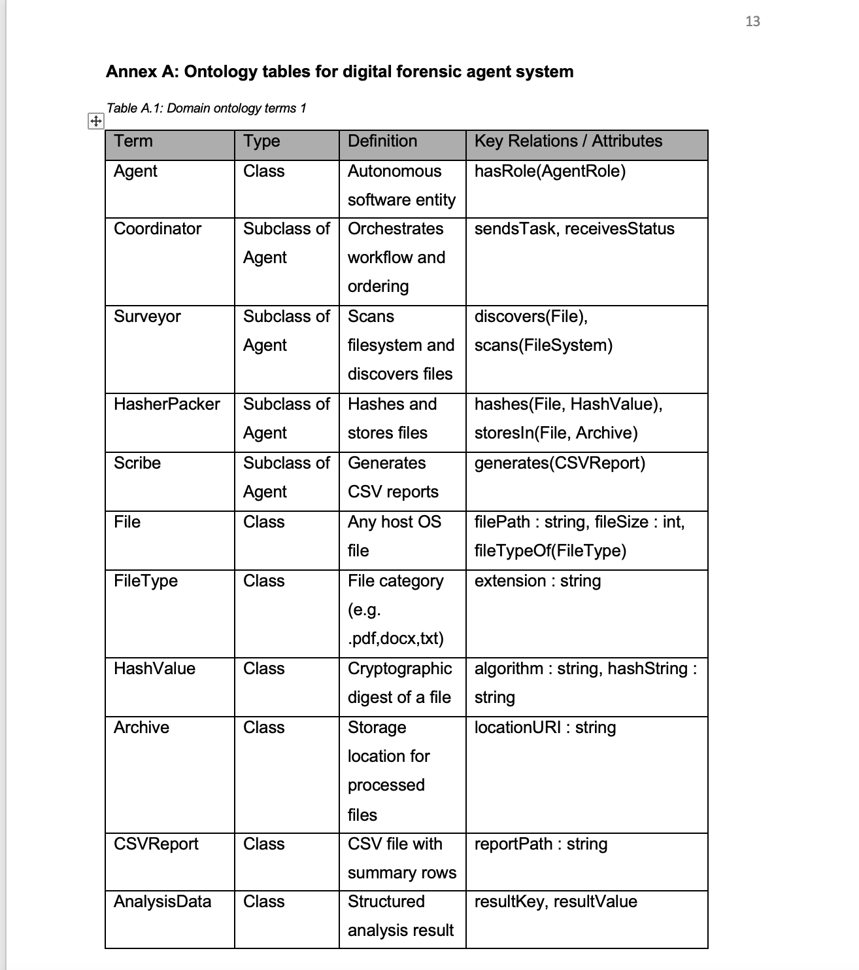

A2. First-Order Logic Rules
I authored FOL rules enforcing:
- Agent typing and role constraints
- Message validity (single sender, defined type)
- Mandatory forensic workflow ordering (discover → hash → store → analyse → report)
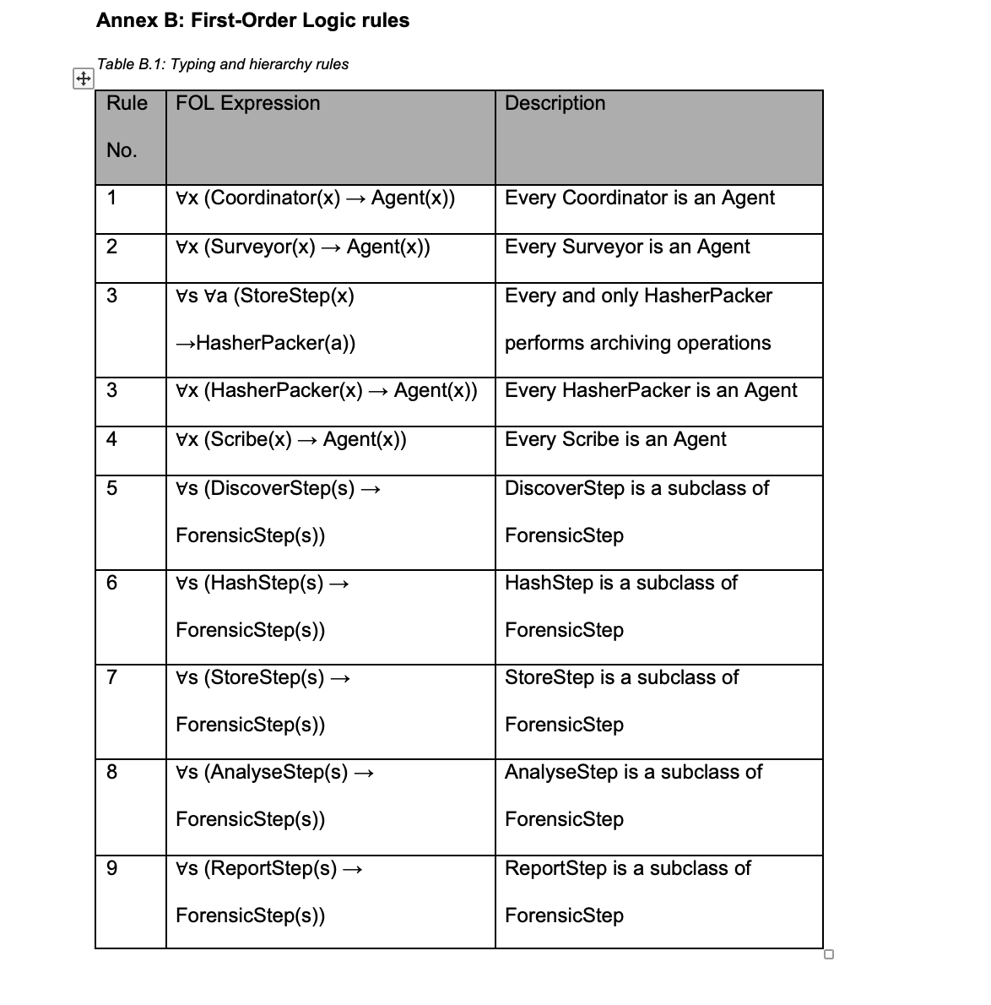
A3. Agent Communication
I contributed to the design of agent communication semantics, drawing on KQML/FIPA-ACL concepts and applying them within a Python-based agent framework.
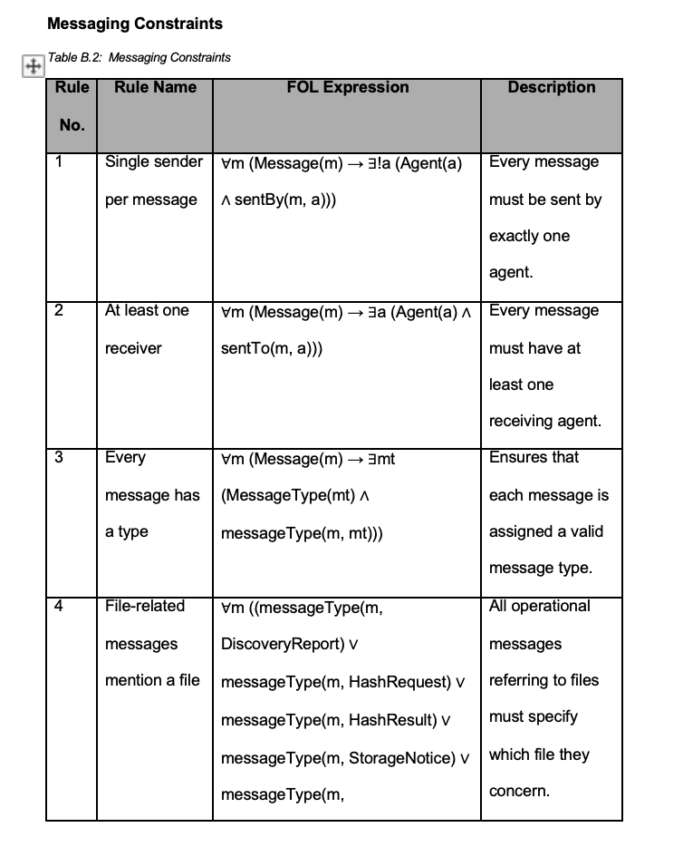
A4: Evidence of Learning -ePortfolio
Title: MSc Intelligent Agents Learning ePortfolio
URL: https://valofili.github.io/eportfolio/
Description:
This ePortfolio contains supplementary artefacts demonstrating the development of foundational and advanced Intelligent Agent concepts, including but not limited to:
- Construction of Agent Dialogues
- Development of Parse Trees
- Implementation of Agent Planning and Reasoning Structures
- Exploration of agent communication protocols (e.g., KQML, FIPA-ACL)
- Demonstration of agent behaviours, ontologies, and rule-based decision processes
These artefacts further evidence the engagement with agent-based modelling, distributed reasoning, and AI systems design, complementing the analytical and statistical modelling skills applied in this coursework assignment.

